*BlackBox Testing*

Acceptance criteria. Username accept letters (A/a-E/e) and digits (1-9). Min lenght-6, max-8. Phone field accept only digits. Min lenght-1, max-7. Submit button is activated when insert valid data to Phone and Username fields.

Test Data

*1.Username*

**Min length - 6։**  A/a-E/e and numbers 1-9

**Max length - 8։** A/a-E/e and numbers 1-9

Valid:

1. ABCD123
2. AabdeC
3. Aabcd1
4. A1B2c3
5. 123456

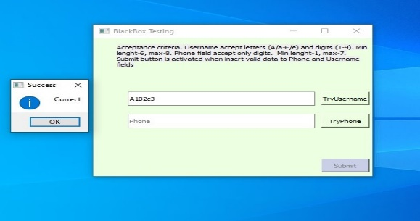 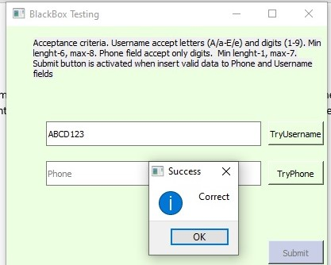

Invalid:

1. AbCdE
2. f1a2c3
3. 0aA1b2c
4. 0123456
5. 010254a

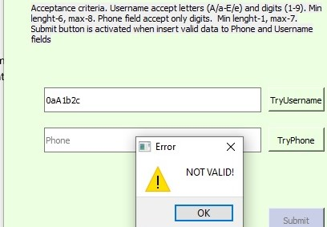

*2.Phone*

**Min length:** Phone field accept only digits - 1

**Max length:** Phone field accept only digits -7

Valid:

1. 56
2. 123456
3. 456213
4. 12345678

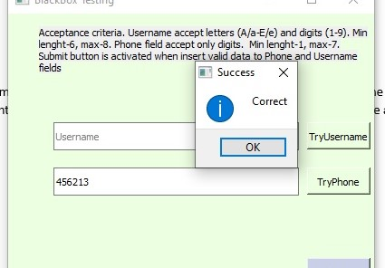

Invalid:

1. 5
2. B11
3. 020345
4. a1568492
5. 0123456

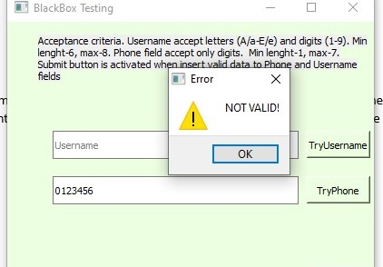

*3.Submit button*

1. Submit button is activated when insert valid data to Phone and Username fields.

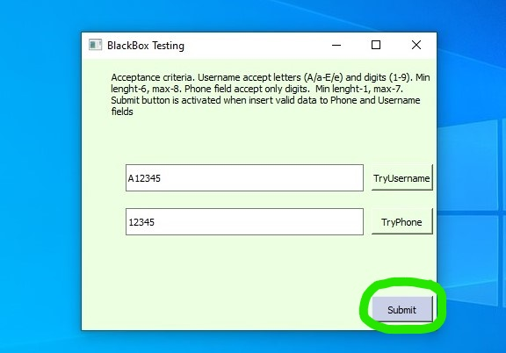

2. Submit button is not activated when insert valid data to Username.

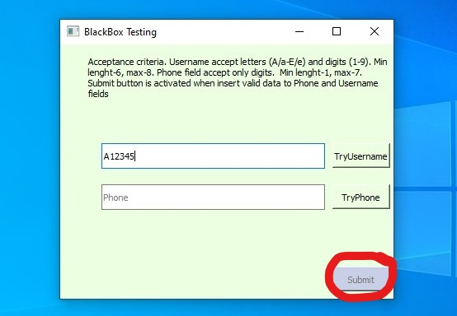

3. Submit button is not activated when insert valid data to Phone.

